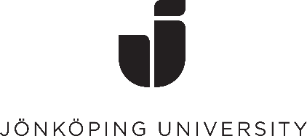

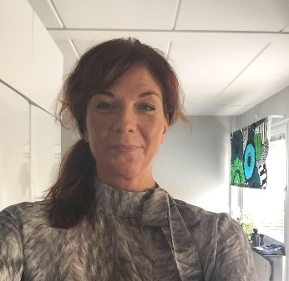
Hej och välkomna till kursen i svenska språket!

My name is Anna and I will be your teacher in Swedish 1 & 2.
The course is a sub-course in the course Pathway Semester and you will study Swedish 4 hours/week.

You can start your Swedish course right now! See links below

Introduction to Swedish language
https://www.youtube.com/watch?v=gRF6Yp8PyYU

https://www.youtube.com/watch?v=h05jhlMAGj4

Swedish alphabet and numbers
https://www.youtube.com/watch?v=wpuscCcxspY
https://www.youtube.com/watch?v=WZQDjLiOnJ0

