Install JU-Printer on Ubuntu 20.04 LTS

- Navigate to https://www.konicaminolta.se/sv-se/support/download-centre
- Search for Bizhub C458, select Linux and then the download link:
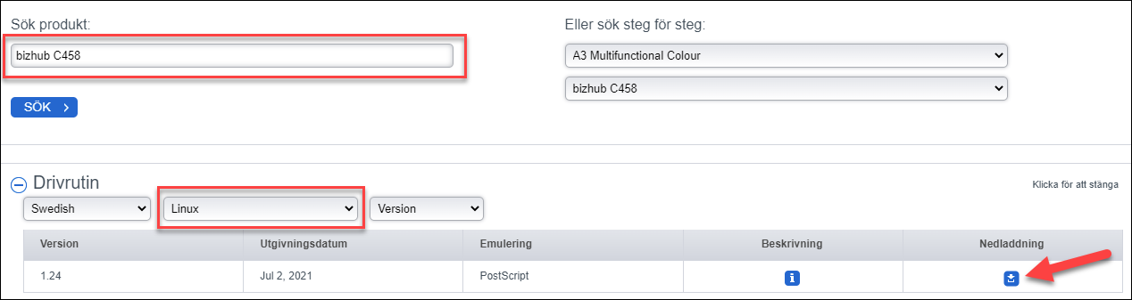
- Choose the file “KMbeuUXv1_24_multi_language.tar.gz”
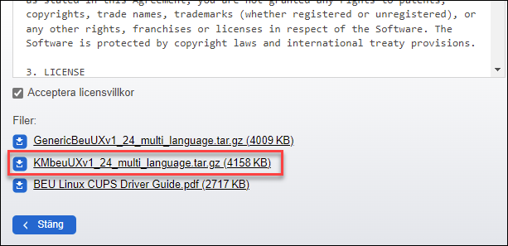
- Extract the files.
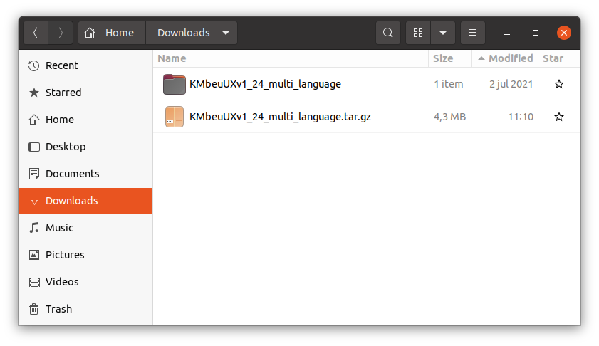

- Open the Terminal and navigate to the extracted folder. Run the installer (install.pl) with sudo.
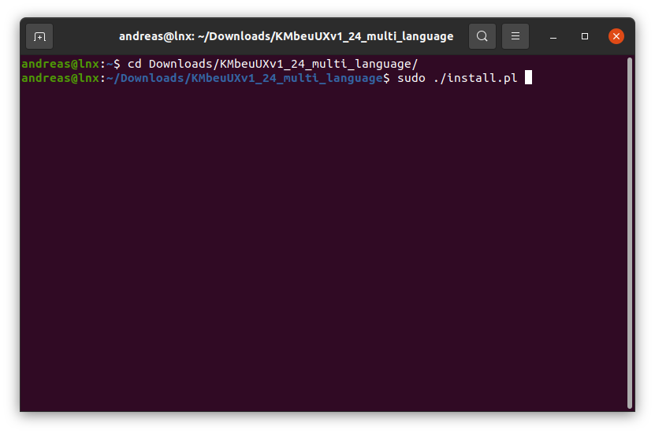
- Follow the instructions according to the screenshots below:
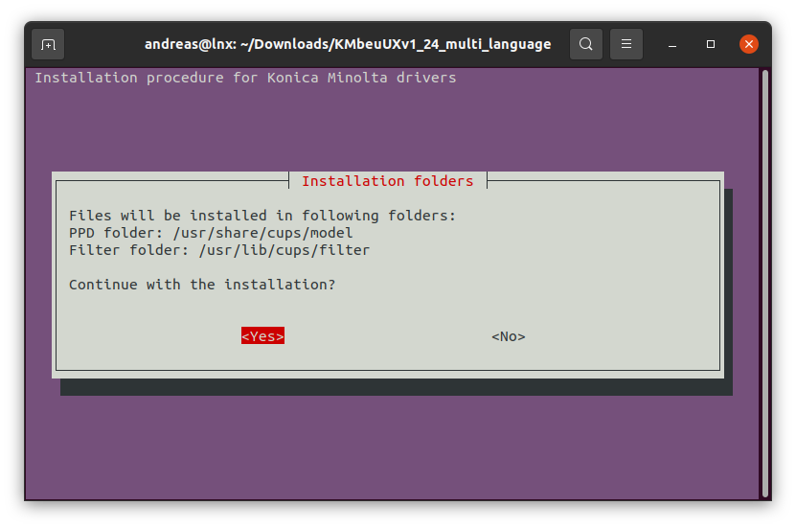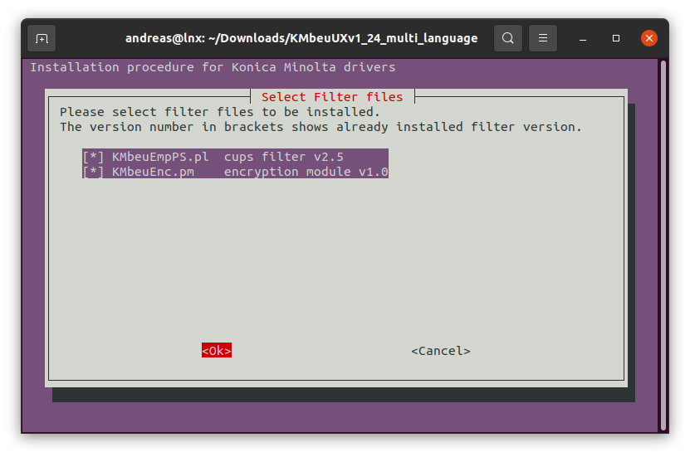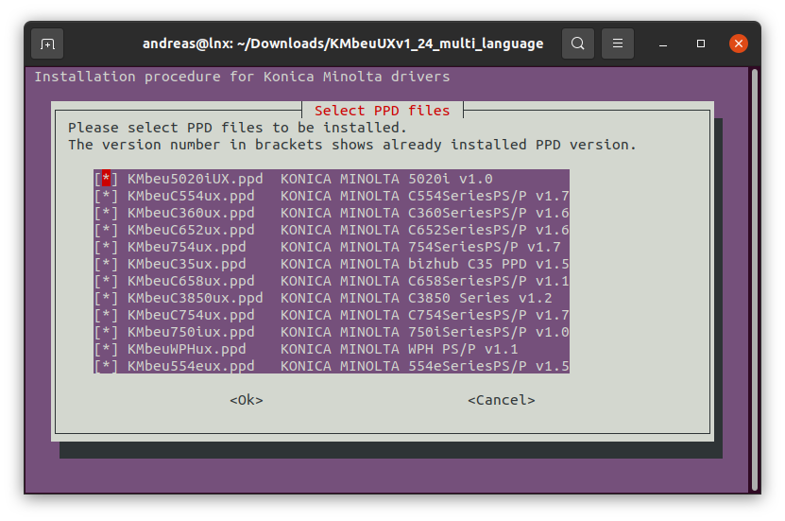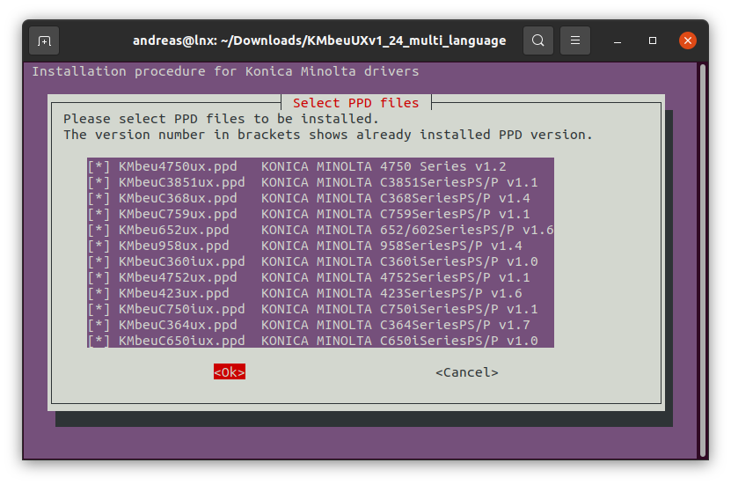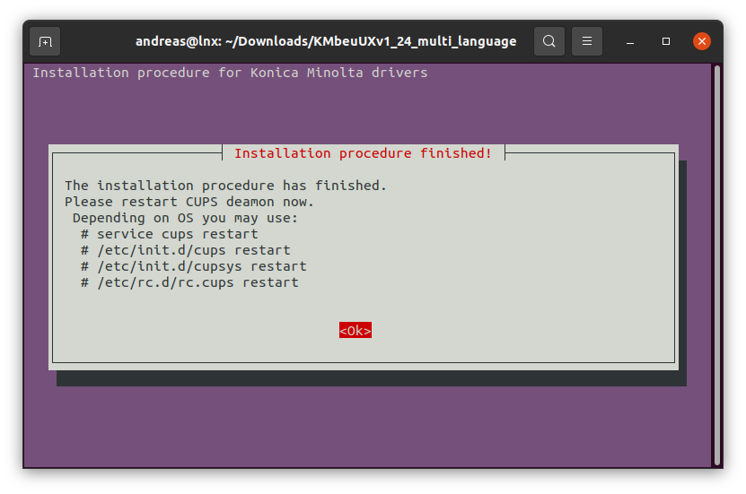

- Restart the cups service.
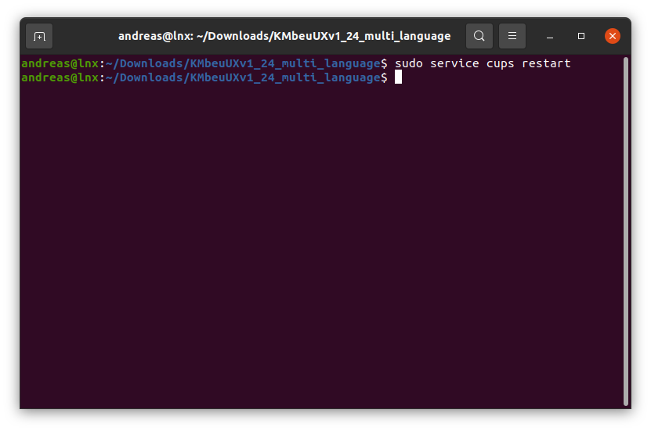
- Open print settings and choose “Additional Settings”.
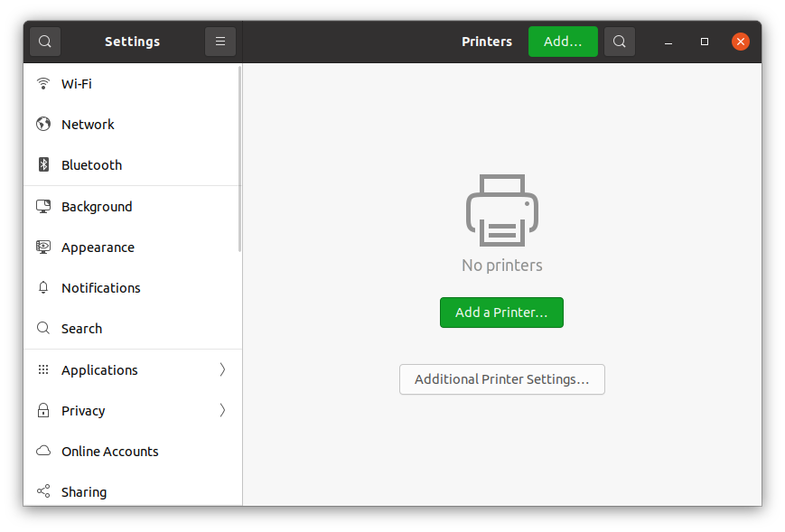
- Choose “Add”
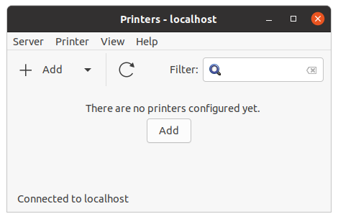

- Add a new printer with “Enter URI”.
Type in the address: lpd://[username]@ju-printq.ju.se/secure

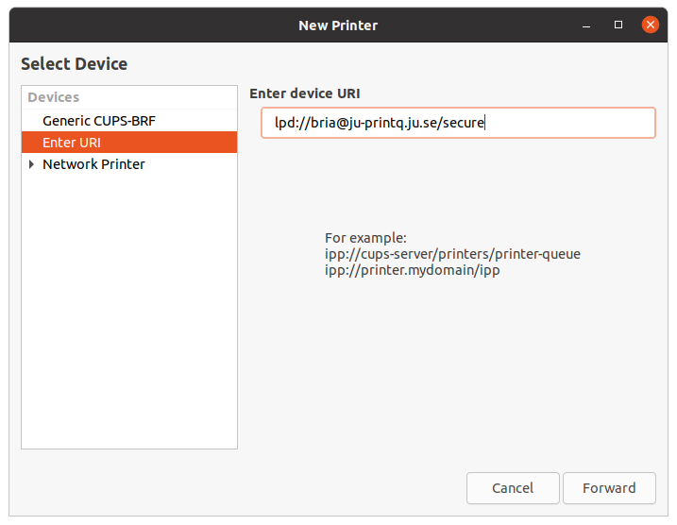
- Select “printer from database” and choose “KONICA MINOLTA”.
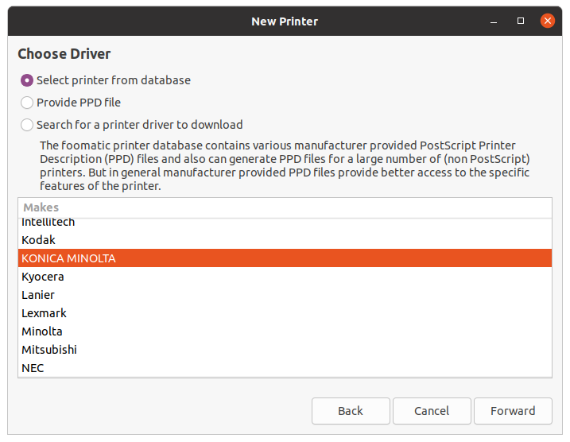
- Choose the driver “C658SeriesPS(P) BEU”.
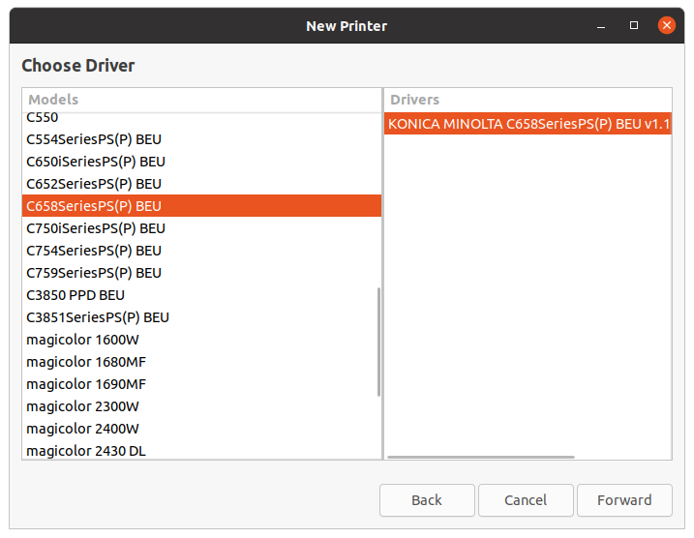
- Choose the printer options according to the screenshot below:
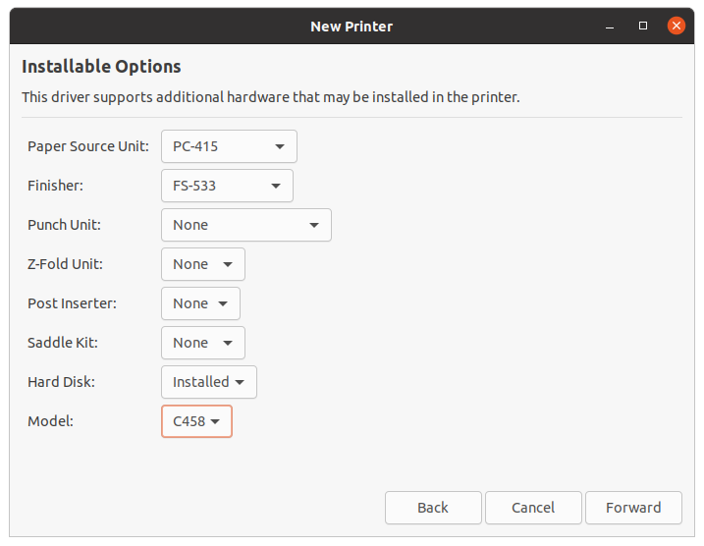
- Set a printer name and choose Apply.
